PROJECT DOCUMENTATION

**PROJECT PLAN**

|  |  |
| --- | --- |
| **Project:** | **Business Management System for Lanka Tools (Pvt) Ltd** |
| Release: | August 2022 |
| Date: | 14th July 2022 |
|  |  |
| **PRINCE2** |  |
|  |  |
| Author: | Ruwanthi Narampanawa (Scheduling Manager) |
| Owner: | Dr Yasas Jayaweera (Project Executive) |
| Client: | Lanka Tools by H.F.Athaf |
| Document Ref: | ProjectPlan_Lanka Tools |
| Version No: | 1.0 |

# 1 Project Plan History

## 1.1 Document Location

This document is only valid on the day it was printed.

The source of the document will be found on the project's PC in location

## 1.2 Revision History

**Date of this revision: 07/14/2022**

**Date of Next revision:**

|  |  |  |  |
| --- | --- | --- | --- |
| **Revision date** | **Previous revision date** | **Summary of Changes** | **Changes marked** |
| 07/14/2022 |  | Added the Financial Budget, Change Budget |  |

## 1.3 Approvals

This document requires the following approvals.

Signed approval forms are filed in the Management section of the project files.

|  |  |  |  |  |
| --- | --- | --- | --- | --- |
| **Name** | **Signature** | **Title** | **Date of Issue** | **Version** |
| Dr.Yasas Jayaweera |  | Project Board | 07/14/2022 | 1.0 |
| Bhathiya Kannangara |  | Project Manager | 07/14/2022 | 1.0 |
| Mr. H.F.Athaf |  | Client | 07/14/2022 | 1.0 |

## 1.4 Distribution

This document has been distributed to:

|  |  |  |  |
| --- | --- | --- | --- |
| **Name** | **Title** | **Date of Issue** | **Version** |
| Bhathiya Kannangara | Project Manager | 07/14/2022 |  |
| Imanka Jayasiriwardena | Startup Manager | 07/14/2022 |  |
| Layan Perera | Quality Manager | 07/14/2022 |  |
| R.A.G.U.T.Rajapaksha | Risk Manager | 07/14/2022 |  |
| Ruwanthi Narampanawa | Scheduling Manager | 07/14/2022 |  |

# 2 Table of Contents

Page

### 1 Project Plan History 2

1.1 Document Location 2

1.2 Revision History 2

1.3 Approvals 2

1.4 Distribution 2

### 2 Table of Contents 3

### 3 Purpose 4

### 4 Plan Description 4

### 5 Prerequisites 4

### 6 External Dependencies 4

### 7 Planning Assumptions 4

### 8 Project Plan

8.1 Work Breakdown Structure 5

8.2 Gantt or Bar Chart 6

8.3 Product Breakdown Structure 7

8.4 Product Flow Diagrams 8

8.5 Product Descriptions 9

8.6 Activity Network 9

8.7 Financial Budget 10

8.8 Change Budget 10

8.9 Resource Requirements 11

8.10 Specific Resources 11

8.11 Tolerance 11

8.12 Contingency Plans 11

# Project Plan

## Purpose

The project plan tries to demonstrate the key deliverables, activities, and resources required for the project and to provide a timeline for when and how the project's goals will be achieved. It gives the Business Case projected project expenses and management phases, and other significant control points. It serves as a starting point from which the Project Board can monitor the development and costs of the project step by stage.

## Plan Description

The briefing will cover important topics on which the system's development will depend, as well as how these topics are expected to be handled given the people and material resources at hand. The planning will cover how the work is break down and what deliverables are expected to be delivered in the due time, aligning to the forecasted time frames. The plan will accompany how the tasks are distributed among the members of the team based on their strengths and the field of expertise.

## Prerequisites

The customer expected the developers to be knowledgeable about user-friendly technology and create a system with strong security in mind.

## Dependencies

This project will be completed using a variety of tools, including Jira for project management, GitHub for document management, Zoom for communication, MS Word, and Google Docs for report authoring.

Other than that, the system will be built using PHP and My SQL.

## Assumptions

The team assume that the client has a basic understanding of IT and can use the user-friendly system after deployment.

## 8 Project Plan

### 8.1 Work Breakdown Structure

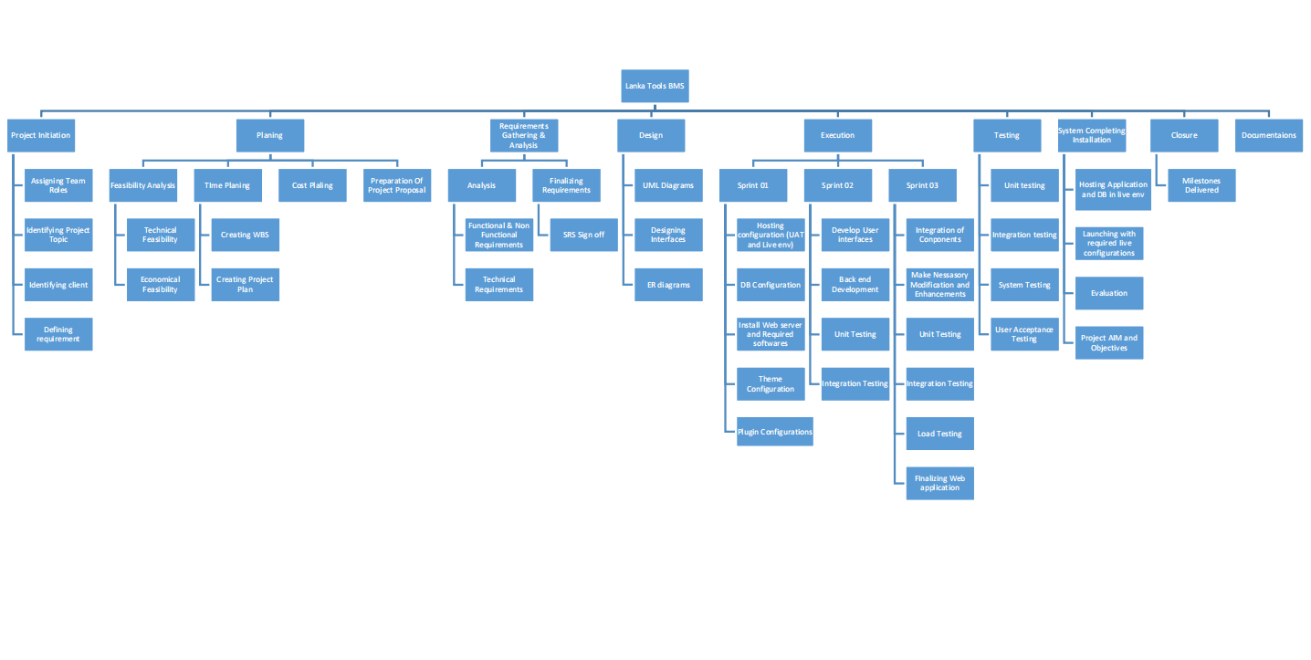

### 8.2 Gantt Chart

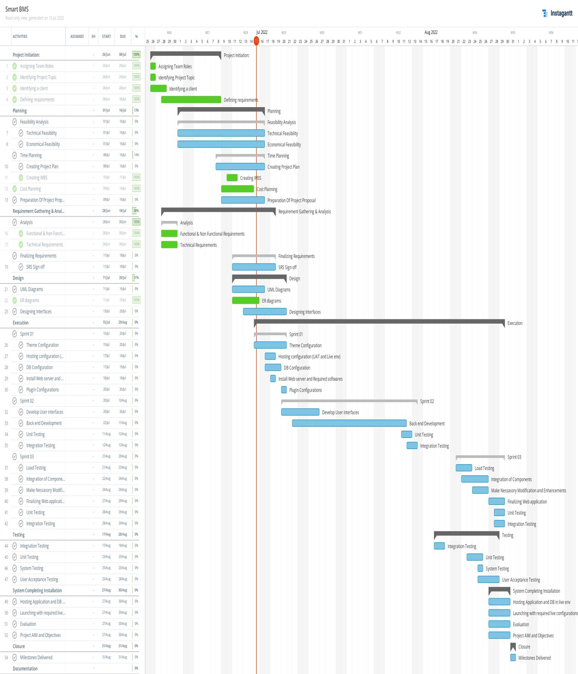

### 8.3 Product Breakdown Structure

### 8.4 Product Flow Diagrams

### 8.5 Product Descriptions

The product description document explains the depth of the product. The final product is a Business Management System which has the following features.

**Admin**

* Login to the system
* Add Employees
* View Employees
* Delete Employees
* Update Employees
* View & manage Budgets
* View & Manage Hourly rates and Salary scales
* View & manage Cash advances
* View & manage Salaries
* Upload Attendance
* View & manage Attendance
* Print Pay slips
* Report Generation

**Employee**

* Log-in to the system
* Creates a user account
* View and Manage Profile
* Add Attendance
* View Attendance
* Update Attendance
* Add Leaves
* View Leaves
* Update Leaves
* Add Cash Advances
* View Cash Advances
* View and Print Pay slips
* View Salary History
* Report Generation

**8.6 Activity Network**

The activity network has been uploaded to the Google Drive. Please be kind enough to refer the following document,

Please refer:

### 8.7 Financial Budget

**Estimated Budget for Lanka Tools**

**By H.F.Athaf**

**(Business Management System)**

|  |  |  |  |  |  |
| --- | --- | --- | --- | --- | --- |
| Expense | Description | Basics | Unit | Rate | Total |
| Project Planning | | | | | |
| **Initial Meeting** | Arranging an initial meeting to get to know the client | Hourly | 2 | 450 | 1350 |
| **Gather Requirements** | Gather details regarding the existing system and the requirements for the new system | Hourly | 4 | 500 | 2000 |
| **Meeting Two (via Zoom)** | Internet charges/Other | Hourly | 3 | 200 | 600 |
| Development | | | | | |
| **Create Wireframes (Front end)** | Sketch and finalize the User Interfaces | Hourly | 9 | 700 | 6300 |
| **Design back end** | Design the backend workflow | Hourly | 7 | 600 | 4200 |
| **Frontend Implementation** | Developing the wireframes into final user interfaces. | Hourly | 35 | 800 | 28,000 |
| **Backend Implementation** | Implementing/Creating Backend functionalities | Hourly | 48 | 900 | 43,000 |
| **Design /Create and Implement the Database** | Develop a proper and secure database for the project | Hourly | 18 | 650 | 11,800 |
| Testing | | | | | |
| **Unit Testing** | Test each and every part specifically when finished. | Hourly | 5 | 500 | 2500 |
| **Final testing** | Perform the final testing of the whole developed system | Hourly | 8 | 600 | 4800 |
| Documentation | | | | | |
| **Document hardcopies** | Copies of all documents as well as the guidelines/user manual | All Documents | - | - | 2000 |
| Setup of the System | | | | | |
| **Multiple API Usage** | Using of separate APIs to perform tasks | No of APIs | 3 | 3000 | 9000 |
| **Total** | | | | | **115,550/=** |

### 8.8 Change Budget

There has been no change in the budget since the client agreed with it.

### 8.9 Tolerance

The clients were kind enough to grant an additional month for the full implementation due to the developers' commitments to their undergraduate project, jobs, and personal lives. However, the project couldn't in any way be of low quality.

### 8.10 Contingency Plans

In the event that any modifications are unintentionally erased from the developers' computer, all the changes will be saved to the webserver's database, daily backups will be made, uploaded to a different cloud service, and all documents will be saved to Google Drive. They are less likely to disappear and prevent the project from moving forward because they are stored in the cloud.